**Worksheet – 1.1**

**Student Name:** Vivek Kumar  **UID:** 21BCS8129

**Branch:** BE-CSE (LEET) **Section/Group:** 808/B

**Semester:** 4th **Date of Performance:** 10/02/2022

**Subject Name:** Computer Network Lab **Subject Code:** 20CSP-257

**1. Aim/Overview of the practical:**

Create a worksheet which elaborates the different transmission medias and steps to create the connector to make an ethernet connection possible.

**2. Task to be done/ Which logistics used:**

* Elaborates the different transmission medias
* Steps to create the connector to make an ethernet connection possible.

**3. Steps for experiment/practical/Code:**

There is Several Types of Transmission media shown in the figure:

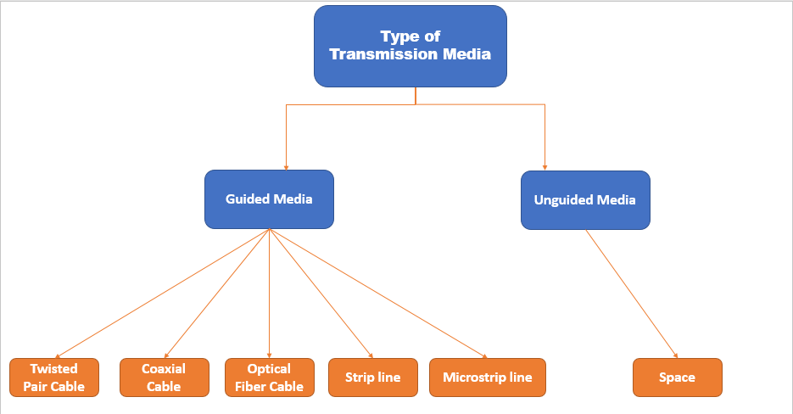

1. **Guided Media:**   
   It is also referred to as Wired or Bounded transmission media. Signals being transmitted are directed and confined in a narrow pathway by using physical links.

**There are 3 major types of Guided Media:**

1. **Twisted Pair Cable –**   
   It consists of 2 separately insulated conductor wires wound about each other. Generally, several such pairs are bundled together in a protective sheath. They are the most widely used Transmission Media.

**Twisted Pair is of two types:**

* 1. **Unshielded Twisted Pair (UTP):**   
     UTP consists of two insulated copper wires twisted around one another. This type of cable has the ability to block interference and does not depend on a physical shield for this purpose. It is used for telephonic applications.

**Advantages:**

* + Least expensive
  + Easy to install
  + High-speed capacity
  + Susceptible to external interference
  + Lower capacity and performance in comparison to STP
  + Short distance transmission due to attenuation
  1. **Shielded Twisted Pair (STP):**   
     This type of cable consists of a special jacket (a copper braid covering or a foil shield) to block external interference. It is used in fast-data-rate Ethernet and in voice and data channels of telephone lines.

**Advantages:**

* + - Better performance at a higher data rate in comparison to UTP
    - Eliminates crosstalk
    - Comparatively faster
    - Comparatively difficult to install and manufacture
    - More expensive
    - Bulky

1. **Coaxial Cable –**   
   It has an outer plastic covering containing an insulation layer made of PVC or Teflon and 2 parallel conductors each having a separate insulated protection cover. The coaxial cable transmits information in two modes: Baseband mode (dedicated cable bandwidth) and Broadband mode (cable bandwidth is split into separate ranges). Cable TVs and analog television networks widely use Coaxial cables.

**Advantages:**

* High Bandwidth
* Better noise Immunity
* Easy to install and expand
* Inexpensive

**Disadvantages:**

* Single cable failure can disrupt the entire network

1. **Optical Fibres Cable –**   
   It uses the concept of reflection of light through a core made up of glass or plastic. The core is surrounded by a less dense glass or plastic covering called the cladding. It is used for the transmission of large volumes of data.

The cable can be unidirectional or bidirectional. The WDM (Wavelength Division Multiplexer) supports two modes, namely unidirectional and bidirectional mode.

**Advantages:**

* Increased capacity and bandwidth
* Lightweight
* Less signal attenuation
* Immunity to electromagnetic interference
* Resistance to corrosive materials

**Disadvantages:**

* Difficult to install and maintain
* High cost
* Fragile

1. **Strip line:**

Strip line is a transverse electromagnetic (TEM) transmission line medium invented by Robert M. Barrett of the Air Force Cambridge Research Centre in the 1950s. Strip line is the earliest form of the planar transmission line. It uses a conducting material to transmit high-frequency waves it is also called a waveguide. This conducting material is sandwiched between two layers of the ground plane which are usually shorted to provide EMI immunity.

1. **Microstrip line:**

In this, the conducting material is separated from the ground plane by a layer of dielectric.

1. **Unguided Media:**

It is also referred to as Wireless or Unbounded transmission media. No physical medium is required for the transmission of electromagnetic signals.

**There are 3 types of Signals transmitted through unguided media:**

* 1. **Radio waves –**   
     These are easy to generate and can penetrate through buildings. The sending and receiving antennas need not be aligned. Frequency Range:3KHz – 1GHz. AM and FM radios and cordless phones use Radio waves for transmission.
  2. **Microwaves –**   
     It is a line-of-sight transmission i.e., the sending and receiving antennas need to be properly aligned with each other. The distance covered by the signal is directly proportional to the height of the antenna. Frequency Range:1GHz – 300GHz. These are majorly used for mobile phone communication and television distribution.
  3. **Infrared –**   
     Infrared waves are used for very short distance communication. They cannot penetrate through obstacles. This prevents interference between systems. Frequency Range:300GHz – 400THz. It is used in TV remotes, wireless mouse, keyboard, printer, etc.

**Steps to Create the Connector:**

***Requirement:* - RJ-45 connector, wire and climping tool**

To make the RJ-45 Connector first of all we have to remember the Colour combination and sequence.

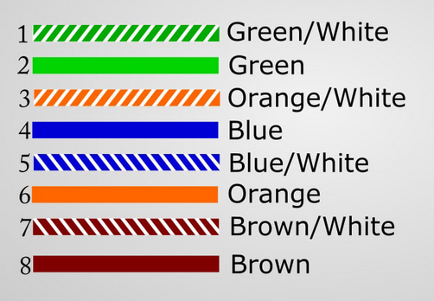

**Step 1:** Strip the cable jacket about 1.5 inch down from the end.

**Step 2:** Spread the four pairs of twisted wire apart. For Cat 5e, you can use the pull string to strip the jacket farther down if you need to, then cut the pull string. Cat 6 cables have a spine that will also need to be cut.

**Step 3:** Untwist the wire pairs and neatly align them in the T568B orientation. Be sure not to untwist them any farther down the cable than where the jacket begins; we want to leave as much of the cable twisted as possible.

**Step 4:** Cut the wires as straight as possible, about 0.5 inch above the end of the jacket.

**Step 5:** Arrange all the wires according to your cable connection needed. such as Straight connection or Crossover connection.

**Step 6:** Carefully insert the wires all the way into the modular connector, making sure that each wire passes through the appropriate guides inside the connector.

**Step 7:** Push the connector inside the crimping tool and squeeze the crimper all the way down.

**Step 8:** Repeat all the steps 1-7 for the other end of the cable. To make the other end connection.

**Step 9:** To make sure you've successfully terminated each end of the cable, use a cable tester to test each pin. When you're all done, the connectors should look like this:

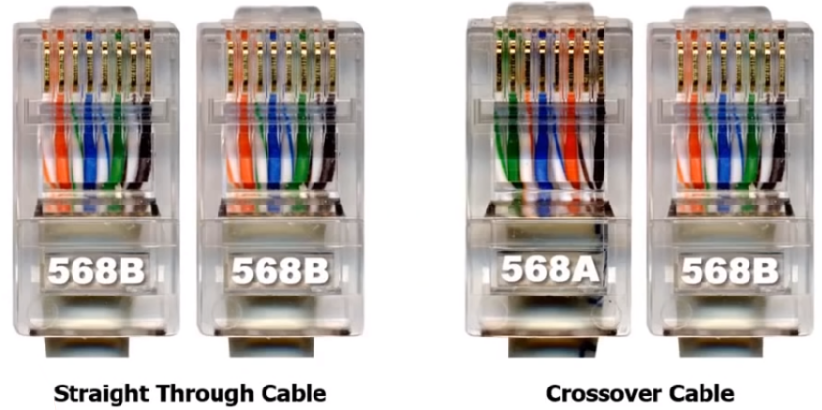

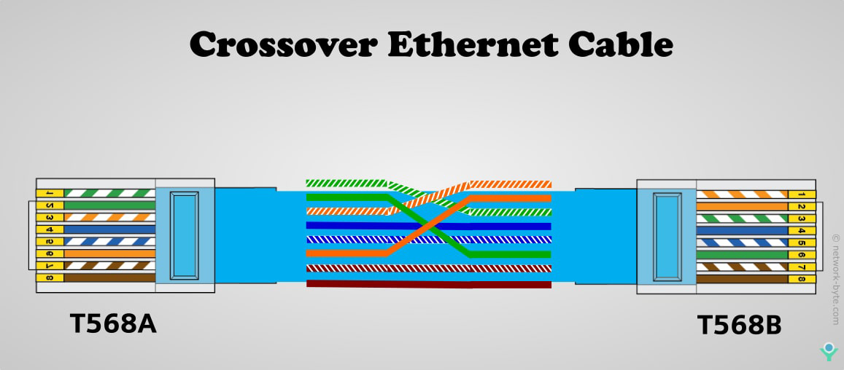

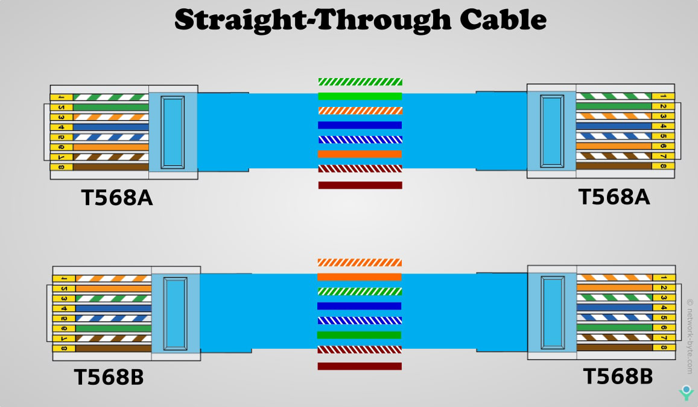

**4. Result/Output/Writing Summary:**

Successfully created the connector to make an ethernet connection possible in all the way. Such as Straight and Crossover.

**Learning outcomes (What I have learnt):**

**1.** Studied about the Different types of cable

**2.** Studied about the making the Straight and Crossover cable connector.

**Evaluation Grid (To be created as per the SOP and Assessment guidelines by the faculty):**

|  |  |  |  |
| --- | --- | --- | --- |
| Sr. No. | Parameters | Marks Obtained | Maximum Marks |
| 1. |  |  |  |
| 2. |  |  |  |
| 3. |  |  |  |
|  |  |  |  |